

**Assignment Cover Sheet**

**Designing Human-Computer Interaction, Assignment 3- Semester 1, 2021**

Course Code: 6389

Tutor Name: Tharanga Samaranayaka Jayawardana

Tutorial Day & Time: Thursday, 05:30 – 07:30

Assignment Topic: Website Evaluation Instrument

Page Count: 10

Date & Time Submitted: when done

**I declare that this assignment is solely my own work, except where due acknowledgements are made. I acknowledge that the assessor of this assignment may provide a copy of this assignment to another member of the University, and/or a plagiarism checking service while assessing this assignment. I have read and understood the University policies concerning Student Academic Honesty.**

|  |  |
| --- | --- |
| **Student ID** | **Signature** |
| U3284513 |  |

# TABLE OF CONTENTS

Contents

TABLE OF CONTENTS 2

EVALUATION TARGET 3

PURPOSE FOR EVALUATION 4

EVALUATION AUDIENCE 4

USERS AND GOALS 4

TOOLS USED 4

EVALUATION 5

INTERACTION 5

UI EVALUATION 5

UX EVALUATION 7

IDENTIFIED ISSUES 8

SOLUTIONS 9

REFERENCES 10

# EVALUATION TARGET

This evaluation will evaluate the Bureau of Meteorology website, covering the usability of the website through the user experience when using the website to perform specify tasks.

Link to website: <http://www.bom.gov.au/>

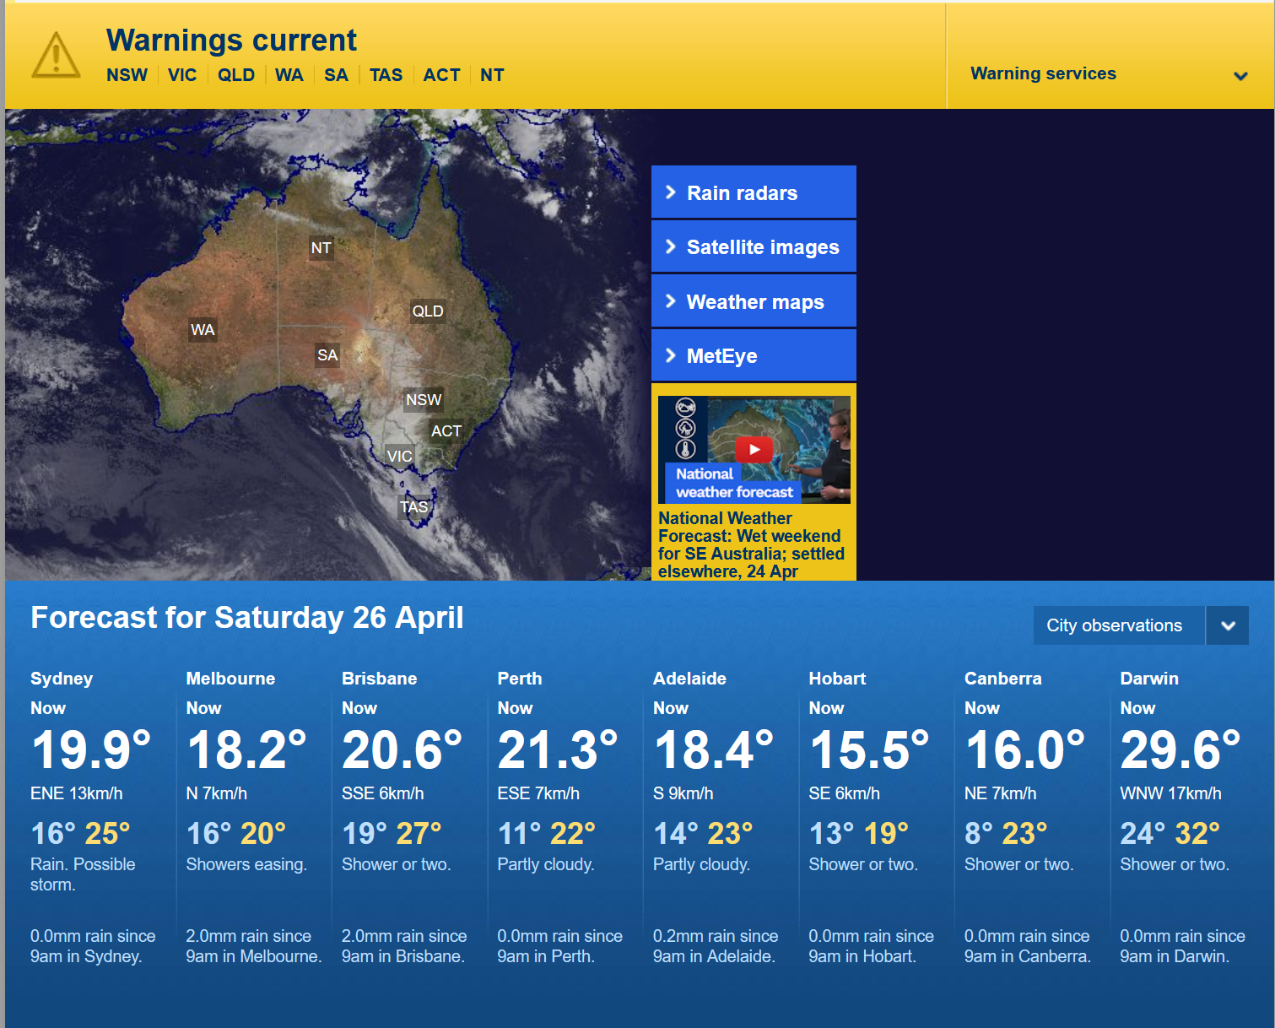

Figure 1: Front page of the website

## PURPOSE FOR EVALUATION

The purpose of this evaluation is to examine how easy it is to use the website. By gathering feedback from different groups of users who actively use this website to make informed decisions, this evaluation will explore usability, accessibility and user experience across the site. Additionally, principles such as how easy it is to navigate through different choices (Yablonski, 2025), how pleasing it is for user to use etc. has been considered in this evaluation instrument.

# EVALUATION AUDIENCE

This evaluation concerns a wide range of user groups who might rely on the service to stay informed or make informed decisions regarding their workflow.

## USERS AND GOALS

This list outlines the potential users of this service, i.e. the Bureau of Meteorology and their end goals while interacting with the service:

* Farmers:
  + Goal: To make informed decisions regarding their crops for the next few weeks/months
* Event planner:
  + Goal: Keeping themselves informed about weather conditions to decide on the best course of action for their client
* Construction worker:
  + Goal: Easy to use and navigate while on the field to make informed decisions about safety practices

# TOOLS USED

This list outlines some tools that were used to aid with the evaluation:

* Google Lighthouse: Used for accessibility and usability issues along with website performance
* SSL Lab: Used to test security measures

# EVALUATION

## INTERACTION

The following table list the interactions done with the website:

* Search and browse for weather information at a specific location
* Search for the website’s contact information
* Opening the rain radar
* Opening the states radar
* Completing feedback form

## UI EVALUATION

|  |  |  |  |
| --- | --- | --- | --- |
| **Criteria** | **Measurement Metrics** | **Collection Method** | **Comment** |
| **Principle 1: Finding information** | | | |
| Is it easy to find contact information? | Yes/No | Expert Review | **Yes.** The website’s contact information can be easily located in the “Contact” tab. |
| Is it easy to submit feedback? | Yes/No | Expert Review | **Yes.** The feedback form can be in the “Contact” tab. |
| Is it easy to find the Accessibility information? | Yes/No | Expert Review | **Yes.** However, the Accessibility guideline used by the website has not been updated since 1999. |
| **Principle 2: Heatmap** | | | |
| How many clicks does it take to find the weather report in the user’s area? | Number of clicks | Self-collected analytics | User average 2 click to find the state weather, 3 clicks to find the area weather. |
| How many clicks does it take to submit a feedback form? | Number of clicks | Self-collected analytics | User average 2 clicks to find the feedback form, 8 clicks to complete and submit the form. |
| How many clicks does it take to find the warning map? | Number of clicks | Self-collected analytics | User average 4 clicks to navigate to the weather warnings. |
| **Principle 3: Navigation** | | | |
| How easy is it for the user to find information on the website? | Numerical, 1 to 10 | Self-conducted analysis | User found that the website was quite easy to navigate, however some elements of the website can be confusing. Average rating is 5. |
| How easy is it for the user to learn to navigate? | Numerical, 1 to 10 | Self-conducted analysis | User found the website to be easy to learn. Average response is 8. |
| How easy is it for the user to find the homepage? | Numerical, 1 to 10 | Self-conducted analysis | User found it easy to find the homepage without guidance. Average rating is 9. |
| **Principle 4: Visibility** | | | |
| How long does it take for the user to find weather information? | Click through | Analytics tool | Average 5 clicks to find weather in a specify area if it is not listed. |
| How long does the user spend finding the contact information? | Click through | Analytics tool | Users spend on average 4 minutes on the “Contact” page. |
| How long does the user spend finding the Privacy information page? | Click through | Analytics tool | Users spend on average 2 minutes finding the page, 5 minutes on the page. |
| **Principle 5: Reliability** | | | |
| Can the user identify if the website is real? | Click through | Survey | User can find the Copyright information, who owns the page and the ABN to verify that it’s real. |
| Can user display all the web pages? | Click through | Analytics | User can display almost all webpages, however some of them have inconsistent sizing. |
| Can users locate a disclaimer notice? | Click through | Survey | User can easily find the Disclaimer notice. |

## UX EVALUATION

|  |  |  |  |
| --- | --- | --- | --- |
| **Criteria** | **Measurement Metrics** | **Collection Method** | **Comments** |
| **Principle 1: Formatting** | | | |
| Does the website have consistent formatting? | Yes/No | Lighthouse Analytics | **No.** The website does not have consistent formatting style. |
| Does the website use contrasting text colour? | Yes/No | Lighthouse Analytics | **Yes.** The website uses different text colour for different purpose |
| Does the website use contrasting back | Yes/No | Lighthouse Analytics | **No.** The website does not use contrasting background colours. |
| **Principle 2: Hierarchy** | | | |
| Does the hierarchy link take the user back to their destination? | Always, Sometimes, Never | Expert Reviews | **98%** response is “Always” |
| Does the hierarchy link display the correct page? | Always, Sometimes, Never | Expert Reviews | **95%** response is “Always” |
| Does the hierarchy allow user to go back in their path | Always, Sometimes, Never | Expert Reviews and Lighthouse Analytics | “Sometimes”, some webpages prevent going back and forth with hierarchy links. |
| **Principle 3: Performance** | | | |
| Does the website function on mobile devices? | Very good, good, average, poor, very poor | Lighthouse Analytics | “Good”, with the first element loading in 0.8s and the website being interactive after 100ms. |
| Does the website function on desktop? | Very good, good, average, poor, very poor | Lighthouse Analytics | “Very good”, with the website loading the first element and being interactive almost instantly |
| Does the pages load correctly? | Very good, good, average, poor, very poor | Lighthouse Analytics | “Good”, with numerous webpages loading normally |
| **Principle 4: Usability** | | | |
| Is the website responsive on mobile device? | Yes/No | Lighthouse Analytics | **Yes**. The webpage is responsive on mobile devices, but some elements are not consistent. |
| Is the website responsive on desktop? | Yes/No | Lighthouse Analytics | **Yes.** The webpage is responsive on desktop with consistent elements. |
| Does the webpages function correctly on both devices? | Yes/No | Lighthouse Analytics | **No.** While the website functions almost flawlessly on desktop, it encounters performance issues on mobile devices. |
| **Principle 5: Functions** | | | |
| Does the search ability function correctly? | Numerical | Survey | Average user response indicates “7” as the search function presents relevant information. |
| Does the search function allow advanced search? | Numerical | Survey | Average user response indicates “6” as sometimes the advanced search function brings them to other websites. |
| Does the webpage display relevant information first when searching? | Numerical | Survey | Average user response indicates “9” as the website display the most relevant information first. |

# IDENTIFIED ISSUES

Through evaluation, certain issues have been identified:

1. The website uses outdated HTTP protocol which is unsecure. This can lead to the website being hacked and taken control of to spread malicious content.
2. The accessibility statement on the website is using an outdated guideline from 1999.
3. The website formatting is inconsistent across some webpages, with some other hierarchy links being completely broken.

# SOLUTIONS

The following solutions have been devised:

1. It was discovered that there is a beta website that has HTTPS protocol enable. The old website should then have a prompt directing users to this new website which is more secure.
2. Update the accessibility statement to the newest version outlined by their guidelines.
3. Ensure that the formatting is consistent across all existing pages, and either removing or redirecting broken hierarchy links.

# REFERENCES

1. Yablonski, J 2025, Choice Overload | Laws of UX, Laws of UX.